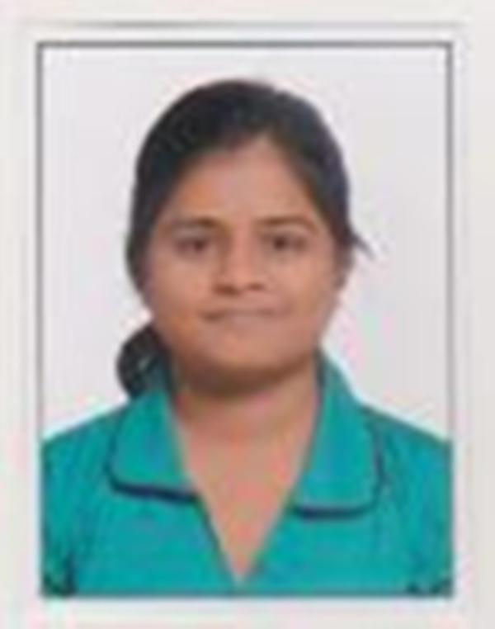
ALEKHIKA MAHAPATRA
E-Mail Id :- alekhika.10@gmail.com
Mobile :- 8712311430

Career Objective :

A career opportunity that would not only provide a platform to display my technical skills but also add to the vast learning experience of life.

Technical Qualification :

Pursued .NET Course in Peers at Hyderabad.

Technical Skills :

- Language Skills C, C++, .Net
- System Environment Microsoft Windows XP/Vista/Seven(7).

Educational Qualification :

Year | Qualification | Institute/University | Grade/Percent
2012 | B.Tech  (Computer Science & Engineering) | Padmashree Krutartha Acharya College Of Engineering,  Bargarh.  (B.P.U.T.) | 6.95/10(CGPA)
2008 | 12th | Madnawati Public School,  Sambalpur.  (C.B.S.E.) | 64
2006 | 10th | Madnawati Public School,  Sambalpur.  (C.B.S.E.) | 69

Extracurricular Activity :

- Participated in Essay competition in school & college.
- Cultural Committee Member of Cultural Festival “SIZZLING”in college.

Personal Details :

Name : Alekhika Mahapatra
Date of Birth : 10th September, 1990
Father’s Name : Mr. Kanhu Charan Mahapatra
Mother’s Name : Mrs. Lily Mahahapatra
Marital status : Single
Hobbies : Listening to Music
Language Proficiency : English, Hindi, Odia(Mother Tongue)
Address : Alekhika Mahapatra
D/O - Mr. Kanhu Charan Mahapatra
At - Majhilane, Nandapara
P.O. - Jharuapara
Dist - Sambalpur, Odisha
Pin - 768001

PLACE : Hyderabad

(ALEKHIKA MAHAPATRA)

